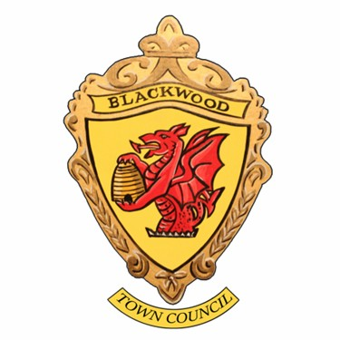

Vacancy for a Town Clerk/Responsible Finance Officer.

Blackwood Town Council is seeking to appoint a highly efficient, multi skilled individual for this varied, responsible and rewarding role of Town Clerk/ Responsible Finance Officer.

The Town Clerk will effectively lead and manage all aspects of the Council’s work, ensuring that the instructions of the Town Council in connection with its function as a local authority are properly actioned. The role requires good committee and administrative experience in a local authority or similar environment, with a sound knowledge of local government systems and procedures.

Applicants will also need a sound knowledge of local government finance and law within the Community/Town Council sector.

The role varies from day to day, and the successful person appointed will have a flexible can-do approach, with enthusiasm and demonstrable commitment to growing in the role as the Town Council develops.

The role is part time at 24 hours per week

Salary : NALC Scale SCP 24-28 - £34,314 - £37,936 per annum based on contracted hours

Working hours to be agreed with the successful candidate but there will be a requirement for regular daytime work ( based at our Offices on Gravel Lane Blackwood ), some evening meetings, and with occasional weekends supporting community events which requires flexibility on the part of the post-holder. A generous package of employee benefits, local government pension scheme and comprehensive training is available for the successful candidate.

If you thrive in a small but varied work environment, like a challenge, enjoy public and community interaction, have a positive, caring, can-do attitude, we very much look forward to hearing from you.

For further details – Employee Specification, Job Description and Application Form please check website

www.blackwoodtowncouncil.org.uk or contact the Clerk [clerk@blackwoodtown.gov.uk](mailto:clerk@blackwoodtown.gov.uk)

The closing date for receipt of Applications is: Friday 8th March 2025